COMMONWEALTH OF SUPERIOR COURT
MASSACHUSETTS CIVIL ACTION
PLYMOUTH, SS.
LYNNE MILLICAN, in )
her individual capacity, )
Plaintiff )
)
vs. )
) NO. 92-2140A
HARVARD COMMUNITY HEALTH PLAN, )
NATALIE SCHULTZ, MAHMOOD NIARAKI, )
BRIAN WALSH, BOSTON IVF, SELWYN )
OSKOWITZ, MICHAEL ALPER, )
Defendants )
AFFIDAVIT OF MICHAEL ALPER, M.D.
I, Michael Alper, M.D., hereby depose and state as follows:
1. I am a physician licensed to practice medicine in Massachusetts since 1979. My license remains in full force and effect. My current place of business is Boston IVF, One Brookline Place, Brookline, Massachusetts.
6. On June 19, 1989, I recommended that the Plaintiff undergo IVF. I continued Plaintiff on Leuprolide ("Lupron"), a fertility drug that had been initially prescribed by one of her previous physicians in January, 1989. I also placed Plaintiff on Pergonal, another fertility drug.
10. With respect to the standard of care pertaining to the drug Lupron, there was no hard and fast rule relating to a six month use limit of the drug in either 1989 or now.
Signed under the pains and penalties of perjury this 20th day of
May, 1993

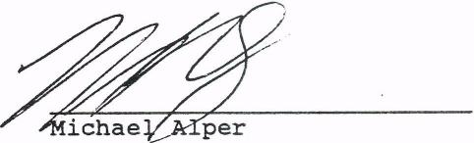
, M.D.

