
COMMONWEALTH OF MASSACHUSETTS
SUPERIOR COURT CIVIL ACTION

PLYMOUTH, SS.

LYNNE MILLICAN, in her individual capacity, Plaintiff
NO.
92-2140A
vs.
HARVARD COMMUNITY HEALTH PLAN, NATALIE SCHULTZ, MAHMOOD NIARAKI, BRIAN WALSH, BOSTON IVP, SELWYN OSKOWITZ, MICHAEL ALPER, Defendants

ANSWERS OF THE DEFENDANT, NATALIE SCHULTZ, TO THE PLAINTIFF, LYNNE MILLICAN’S INTERROGATORIES (FIRST SET)

Q1. Please identify yourself fully.
A1. My name is Natalie Schultz. I am a physician and my specialty is obstetrics and gynecology. My place of business is Harvard Community Health Plan, One Fenway Plaza, Boston, Massachusetts.

Q13. Kindly describe fully and in complete detail any and all symptoms, complaints, or physical response to the drug Lupron that you observed in the Plaintiff or which was complained of to you by the Plaintiff, and state with particularity any and all reasons for you to ascribe the Plaintiff's insomnia to "stress" rather than as a drug induced side effect.
A13. It was much more medically likely that the Plaintiff's symptoms were stress induced.
Q14. Please describe fully and in complete detail any and all information you knew at the time of this cause of action concerning the drug Lupron, including but not limited to, indications and usage, clinical pharmacology, contraindications, warnings, precautions, overdosage, and management of side effects, and set forth any and all knowledge you had regarding Lupron being an experimental drug, and state with particularity the source and the date of any and all knowledge.
A14. Please refer to the 1989 Physician’s Desk Reference. Lupron was not and is not considered an experimental drug.
Q15. Kindly state the number of patients on Lupron which you treated prior to and during the time of this cause of action, and state with particularity the number of months these patients had taken Lupron, and set forth whether or not these patients were given supplemental hormones, and identify the means which you are relying upon to enable you to provide numbers.
A15. OBJECTION OF COUNSEL: This is beyond the scope of permissible discovery under Rules 26 and 33 of the Mass. R. Civ. P. in that it seeks information about matters not related to this case, matters which are irrelevant and immaterial.
Otherwise answering, I do not remember the number of patients but it was a large number. Some patients received supplemental hormones. Patients received medication for a variable number of months.
Q20. Kindly describe fully and in complete detail any and all recommendations, prescriptions, or treatment plans you advised for the management of the Plaintiff’s disease following cessation of Lupron therapy, and state with particularity whether any documentation of any and all actions or advice exist.
A20. I have no memory of any discussion of long-term treatment plans.

Subscribed under the penalties of perjury at
Boston

BLOOM, BBO #046520
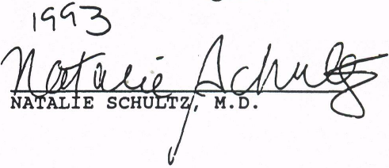
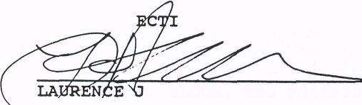

Massachusetts this
8/13 of
/ 1993
AS TO OBJ
ONS OF COUNSEL:
BLOOM AND BUELL
Attorney for Defendant,
Natalie Schultz, M.D.
1340 Soldiers Field Road,Suite Two
Boston, Massachusetts 02135
617) 254-4400

